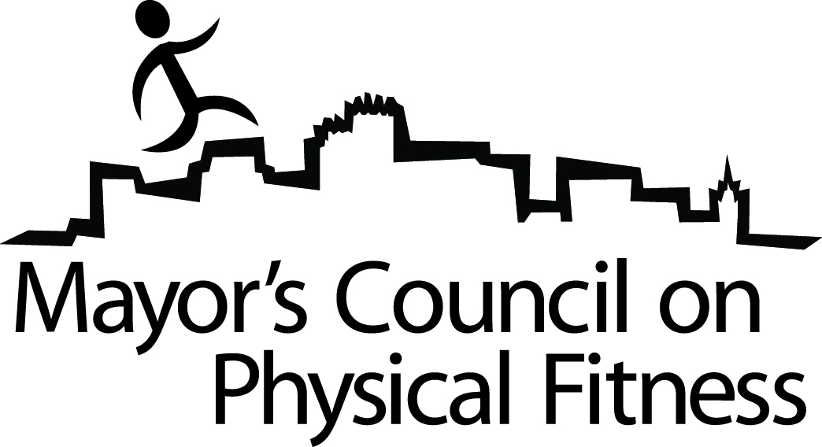

Minutes
Mayor’s Council on Physical Fitness
April 8, 2009
4:00 PM
Abilene City Hall
Basement Conference Room

The Mayor’s Council on Physical Fitness regularly scheduled meeting was cancelled.

